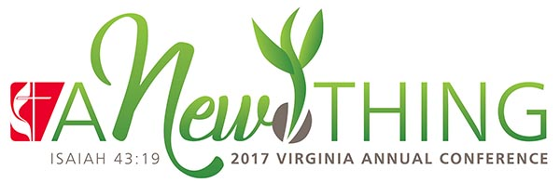
2017 CHARGE CONFERENCE AGENDA
A G E N D A
Welcome
Call to Worship
Opening Prayer
Hymn
2017 Church/Charge Report
Charge Conference Lesson -- “A New Thing” Rev. Wayne Snead, District Superintendent
Holy Communion
† † † † † † †
Charge Conference Business led by the District Superintendent
Election of Recording Secretary
Clergy Compensation Items:
Clergy Compensation Report
Accountable Reimbursement
Parsonage/Housing Exclusion
Pastor’s Statistical Report
Approval of Lay Servant Reports
Approval of Nominations/Lay Leadership
Hymn
Sending Forth to Make Disciples
“A Disciple of Jesus Christ is a Life-long Learner Who Influences Others to Serve”
--Bishop Sharma Lewis, 2017 Annual Conference

